# **Chapter 6****: Configuration Management**

All project are saved in two locations. One is in the local device in which the all the files are created and next one is in GitHub (<https://github.com/maharjansumina/Computing-Project>) which is under the title – Computing-Project. These two locations are in sync using the Git Bash.

Configuration Management is the body of collection of tools, activities, methods and projects. Member of project can use configuration management for managing items in the time of project life cycle. The project composition, project documentation and other supporting project is addressed.

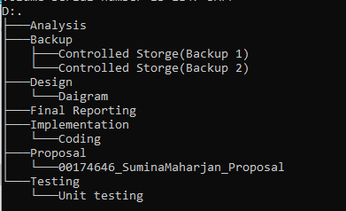

**Figure 11: Configuration Management**

I have divide the task of my project in various phases including its deadline. To complete the project proposal I have separated 16 days in which inside it different days are separated for planning, scoping, questionnaire, and monitoring and controlling. All the analysis will be complete within 28 days dividing those days for feasibility study, requirement analysis, use case diagram and architecture so to be ensure that the application will be created with all the needs that of the people. For the design I will be separating 26 days for designing various diagram. 21 days will be there to complete the implementation where all the coding are written to develop application. I will be assigning total of 7 days for performing testing of the application. In which 4 days will be for Unit Testing and 3 days for Testing. Finally at last Final Document will be created and for final document I will be assigning total of 11 days in which documentation and final reporting will be complete.